

3Dfx Initialization Hardware Abstraction Layer

Revision 0.1
December 23, 1996
Copyright © 1996 3Dfx Interactive, Inc. All Rights Reserved

3Dfx Interactive, Inc.
415 Clyde Ave., Suite 105
Mountain View, CA 94043
Phone: (415) 934-2400
Fax: (415) 934-2424

Introduction
Structure of the HAL
API Reference
initDeviceSelect
initSetWriteMethod
initMapDevice
initAllocBuffers
initSwapBuffers
initStatus
initResetRegisters
InitIdle
initYOrigin
initBusy
initIOCtl
initShutdown
initGamma
initInitSli
initSliPciOwner
initShutdownSli
Device Dependent Layer
SST1
IOCtls
SST96
IOCtls

Introduction
This document describes the hardware abstraction layer used by 3Dfx proprietary software. This layer provides a way for Glide and other 3Dfx APIs and drivers to initialize different chips that 3Dfx develops and manufactures.

Structure of the HAL
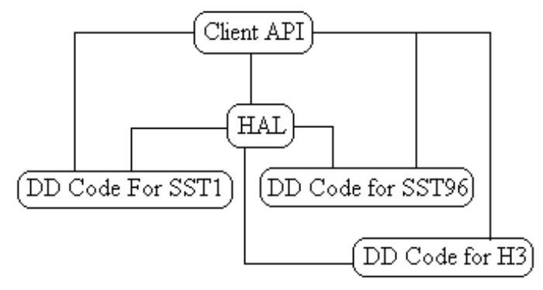
Figure 1: Structure of Init HAL
As indicated in Figure 1, the client API calls the initialization hardware abstraction layer to map devices into linear memory and to initialize them. This allows a rendering API such as Glide to contain mostly code that is applicable to a given family of products (for example, products based on SST1 such as VG96, H3, and Neptune). The lines in Figure 1 which run from the Client API to the device-dependant code indicate a callback method specified to the init HAL by the client. This callback is used in cases where it is the client’s responsibility to manage command transport (for example, SST-96 and H3).

API Reference

initDeviceSelect
C Specification
FxBool initDeviceSelect( FxU32 devNumber );
Description
initDeviceSelect() is used to select a given 3Dfx PCI device. The number of that device is generated by iterating through all the supported devices in the system and assigning increasing numerical IDs to them.

initSetWriteMethod
C Specification
void initSetWriteMethod( InitWriteCallback *wcb );
Description
initSetWriteMethod() is used to specify a callback which the device-dependent code will use to send commands and data to the device. This is not needed for all device types.

initMapDevice
C Specification
FxU32 *initMapDevice( void );
Description
initMapDevice() is used to map the supported device into linear memory.

initAllocBuffers
C Specification
FxBool initAllocBuffers( InitBufferDesc *desc );
Description
initAllocBuffers() is used to allocate the appropriate number of color and depth buffers, as well as initialize the video for full-screen apps, and the window for windowed apps.

initSwapBuffers
C Specification
InitSwapType initSwapBuffers( FxU32 code );
Description
initSwapBuffers() is used to swap the output and rendering buffers. This process may differ greatly on various platforms, and may be different for windowed vs. full-screen apps on a given platform, hence it belongs in the HAL.

initStatus
C Specification
FxU32 initStatus( void );
Description
initStatus() is used to return the contents of the status register from the supported device.

initResetRegisters
C Specification
FxBool initResetRegisters( void );
Description
initResetRegisters() is used to initialize the init registers of the supported device.

InitIdle
C Specification
void initIdle( void );
Description
initIdle() returns when the supported device is no longer active. This is useful for solving race conditions.

initYOrigin
C Specification
void initYOrigin( FxU32 origin );
Description
initYOrigin() sets up the Y origin for the supported device. This can be either the upper-left or lower-left corner of the screen or window.

initBusy
C Specification
FxBool initBusy( void );
Description
initBusy() indicates that the supported device is currently rendering. The differences in determining this on various supported devices is such that it warrants an entry point in the init HAL.

initIOCtl
C Specification
void initIOCtl( FxU32 token, void *argument );
Description
initIOCtl() is a mechanism for accessing additional functionality in the device-dependent code for the init HAL without extending the API.

initShutdown
C Specification
void initShutdown( void );
Description
initShutdown() shuts down the supported device, terminates the state for full screen, or closes the associated window—whichever is appropriate given how the device was initialized.

initGamma
C Specification
void initGamma( double gamma );
Description
initGamma() initializes the gamma correction for the supported device.

initInitSli
C Specification
void initInitSli( FxU32 *regBase0, FxU32 *regBase1 );
Description
initInitSli() initializes scan-line interleaving on the supported device—if said device has this capability.

initSliPciOwner
C Specification
void initSliPciOwner( FxU32 *regbase, FxU32 owner );
Description
initSliPciOwner() initializes the ‘master’ scan-line interleaved device—if the supported current device supports scan-line interleaving.

initShutdownSli
C Specification
void initShutdownSli( FxU32 *regBase );
Description
initShutdownSli() shuts down a scan-line interleaved device.

Device Dependent Layer

SST1

IOCtls

INIT_VIDTIMINGS_IOCTL
The video timings IOCtl allows the user to specifiy a specific timing structure for a display device that is not otherwise supported by the init HAL.

SST96

IOCtls
There are no SST96-specific IOCtls

